**Experiment-1**

1. Install Virtualbox

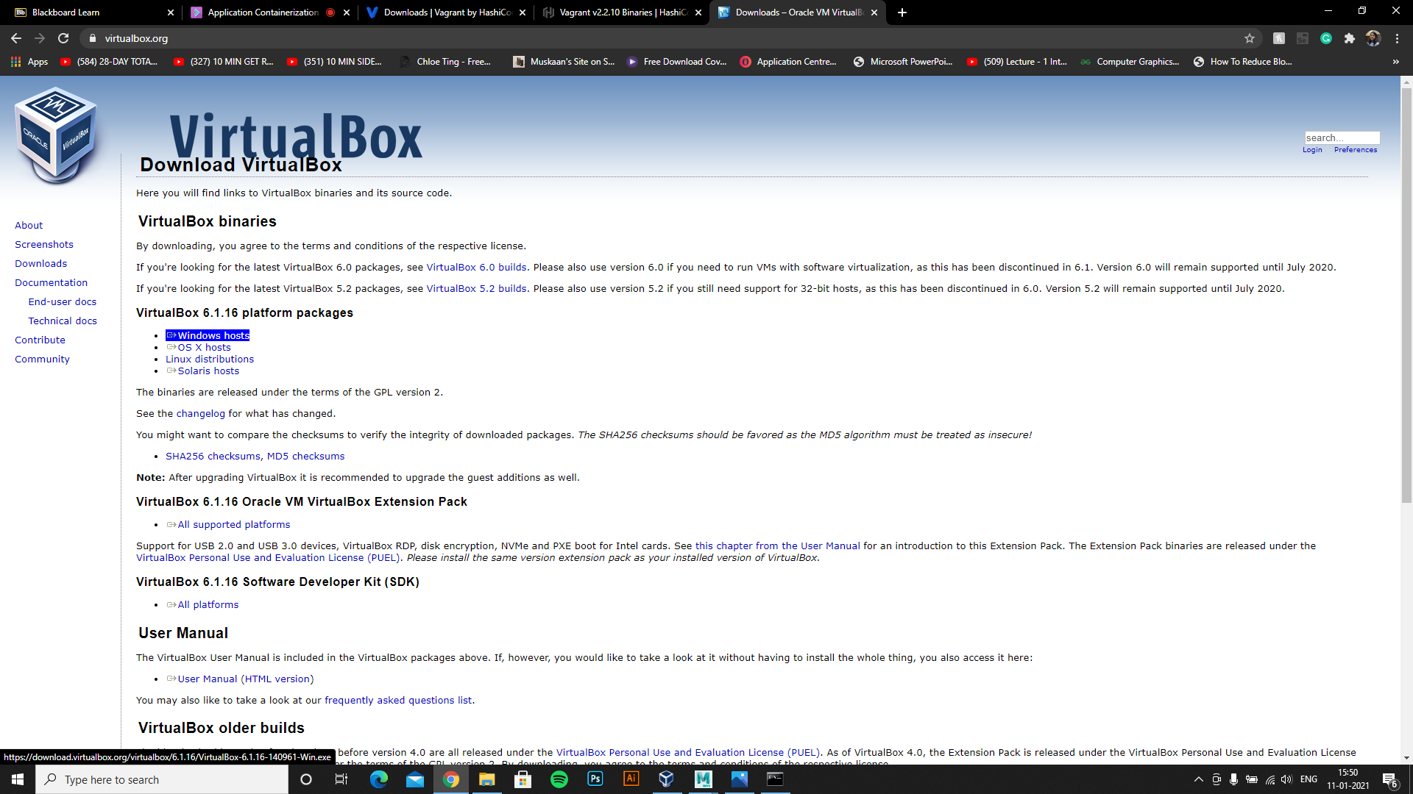

1. Install Vagrant and run vagrant –version in cmd.

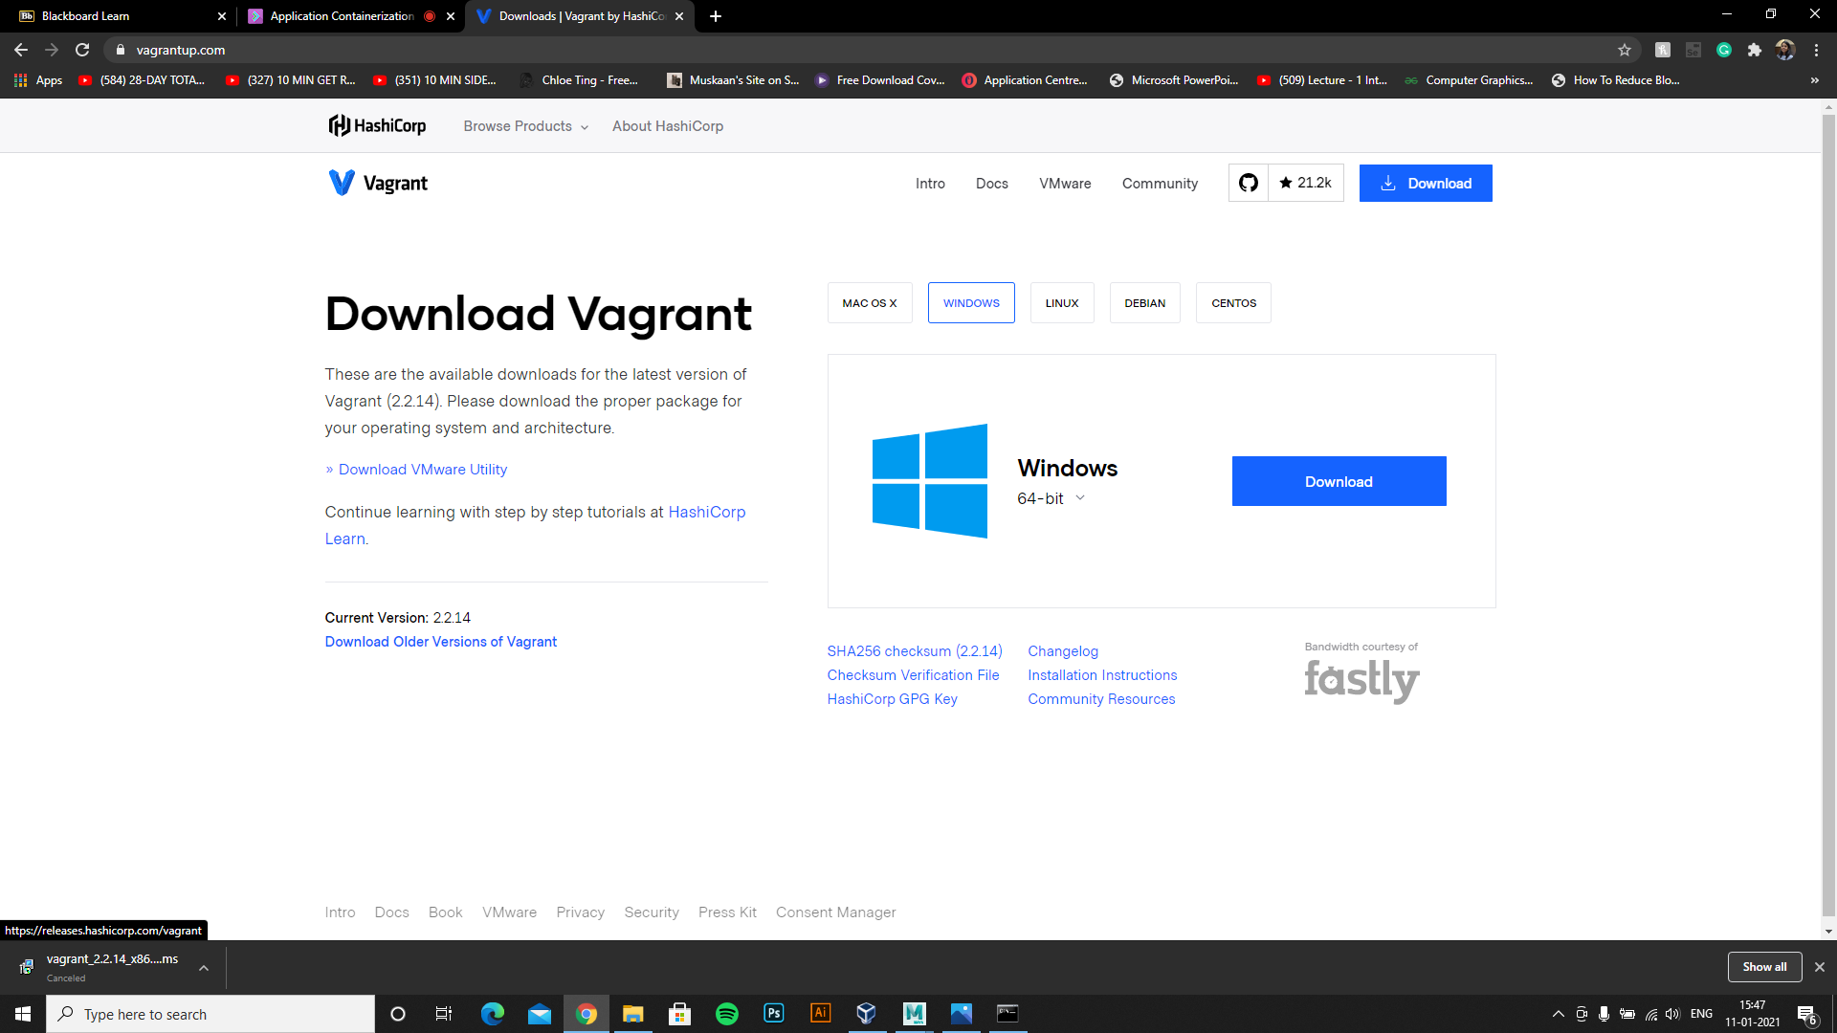

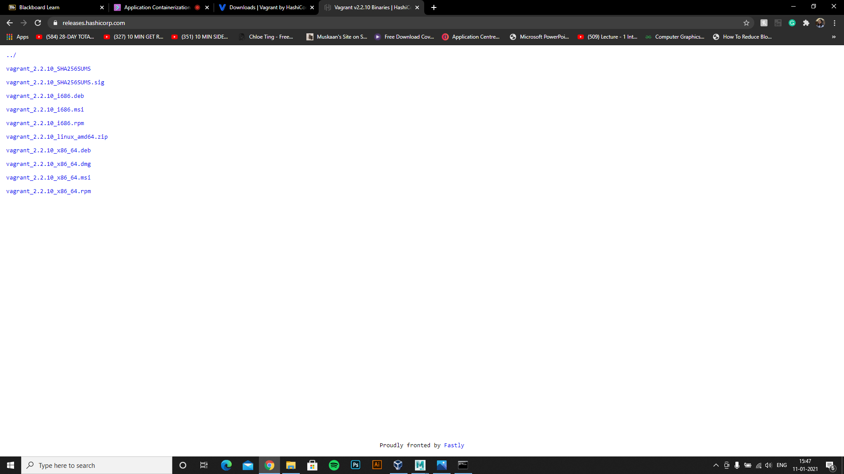

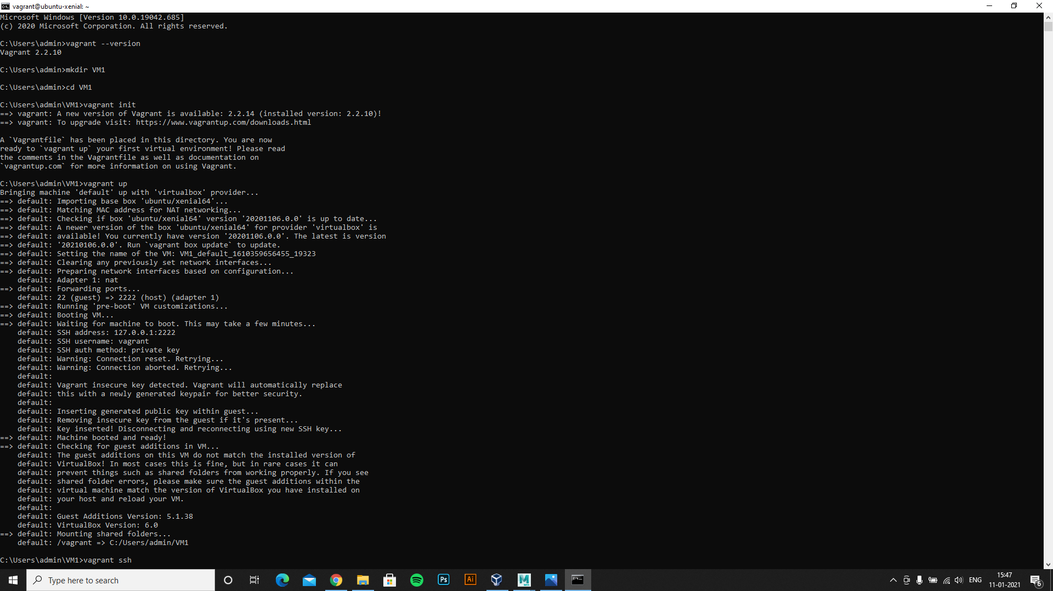

3-Create Folder and go into the folder using cmd



4-Run “**vagrant init**”



5-Edit Vagrant file and write config.vm.box = "ubuntu/xenial64" and save it.

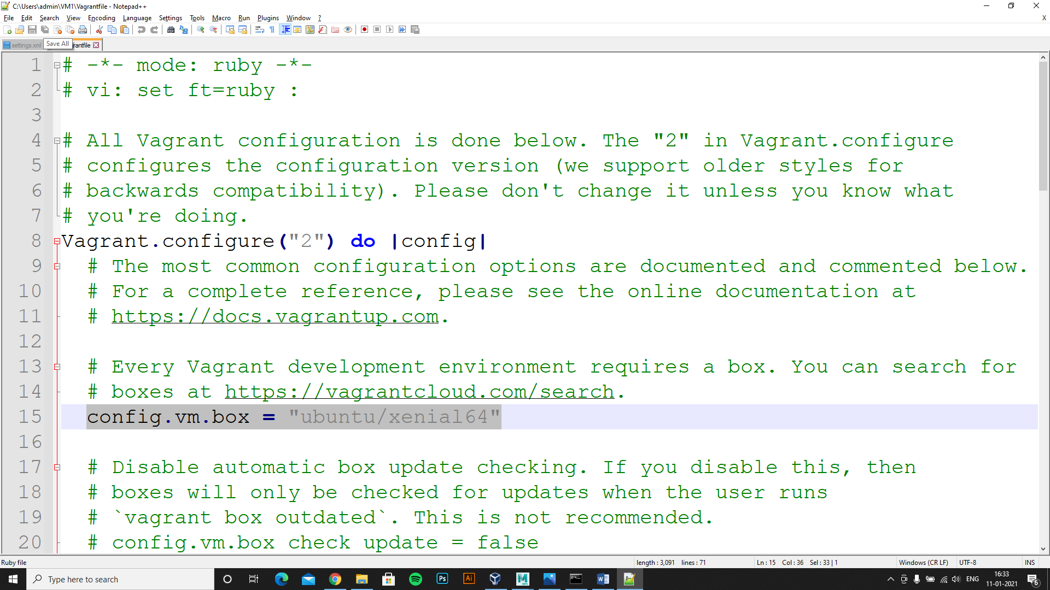

6- Run “**vagrant up**” command in cmd



7-Run “**vagrant ssh”**

